**MongoDB—NoSQL Document Store—Employee Training Score Analysis**

**Analyze Employee Training score data**

**PQR Corp** is a leading corporate training provider. A lot of prestigious organizations send their employees to PQR Corp for training on different skills. As a distinct training provider, PQR Corp has decided to share analysis report with their clients. This report will help their clients know the employees who have completed training and evaluation exam, what are their strengths, and what are the areas where employees need improvement. This is going to be a unique selling feature for the PQR Corp. As PQR Corp is already doing great business and they give training to a large number of people every month, they have huge amount of data to deal with. They have hired you as an expert and want your help to solve this problem.

Attributes of data:

1. Id : id of the person who was trained
2. Name : name of the person who was trained
3. Evaluation : evaluation term
4. Score : score achieved by the person for the specific term

A person can undergo multiple evaluations. Each evaluation will have a unique result score.

You can see the sample data below.

**Sample Data**

*{*

*"\_id":0,  
"name":"Ancy",  
"results": [*

*{"evaluation":"term1","score":1.463179736705023},  
{"evaluation":"term2","score":11.78273309957772},  
{"evaluation":"term3","score":6.676176060654615}*

*]*

*}*

PQR Corp has assigned the following tasks to you to analyze the results:

1. Find count and percentage of employees who failed in term 1, the passing score being 37
2. Find employees who failed in aggregate (term1 + term2 + term3)
3. Find the Average score of trainees for term1
4. Find the Average score of trainees for aggregate (term1 + term2 + term3)
5. Find number of employees who failed in all the three (term1 + term2 + term3)

Find the number of employees who failed in any of the three (term1 + term2 + term3)

### Step 1: Setting Up MongoDB Compass

1. Download and Install MongoDB Compass: If MongoDB Compass is not already installed, download and install it from the [official MongoDB website](https://www.mongodb.com/products/compass" \t "_new).
2. Connect to MongoDB: Open MongoDB Compass and connect to your MongoDB instance. This could be a local instance (mongodb://localhost:27017) or a remote instance.

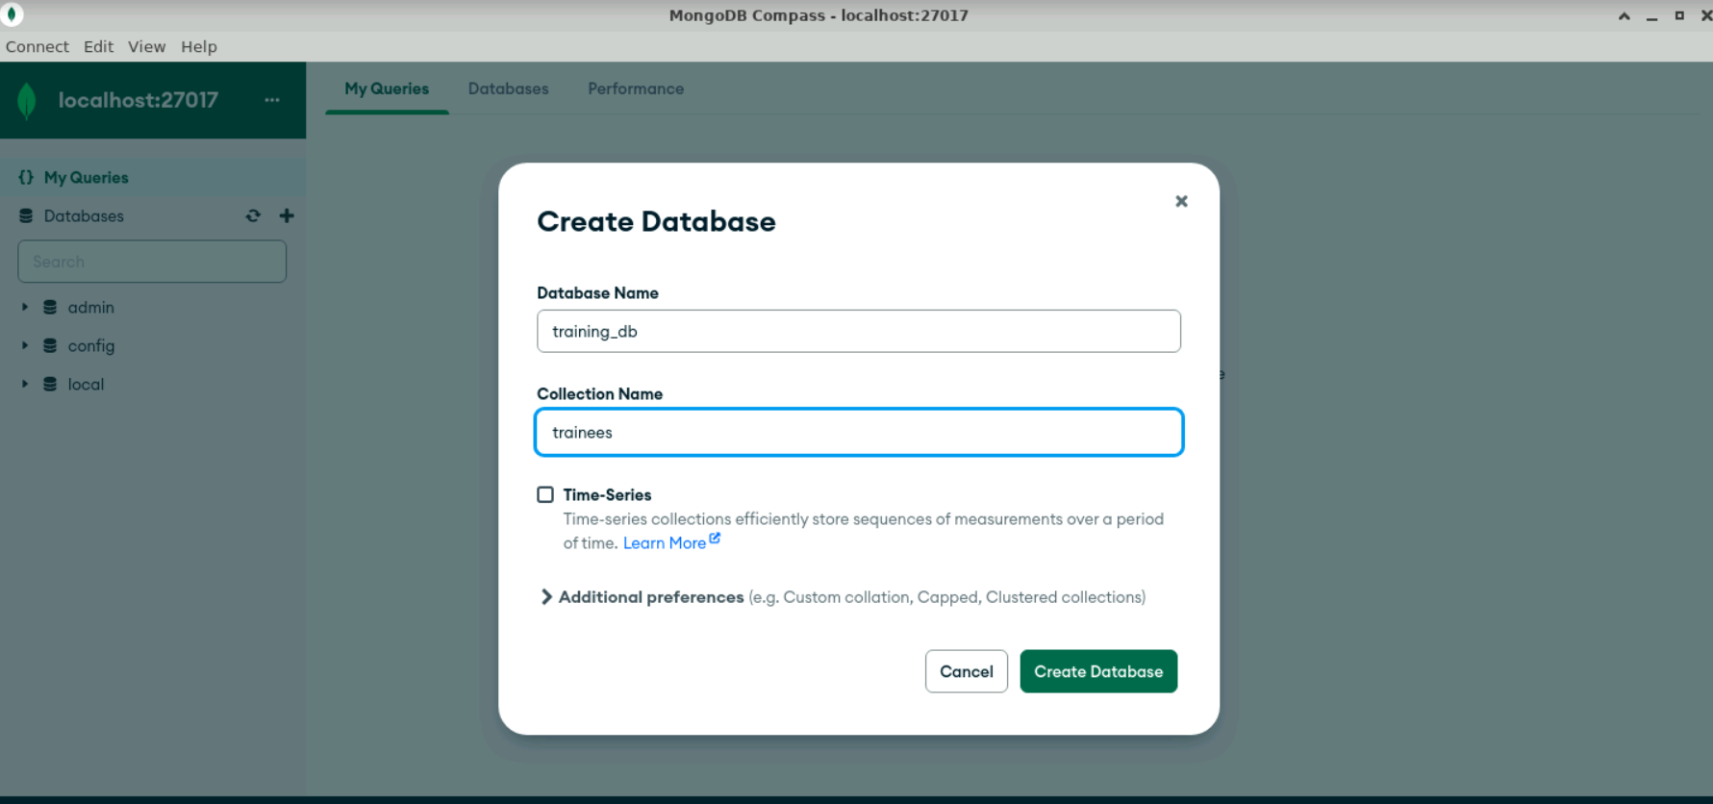

### Step 2: Loading Data into MongoDB using MongoDB Compass

1. **Create a Database and Collection**:
   * Click on Create Database.
   * Enter the database name as training\_db.
   * Enter the collection name as trainees.
   * Click Create Database.
2. **Insert Sample Data**:
   * In the trainees collection, click on Insert Document

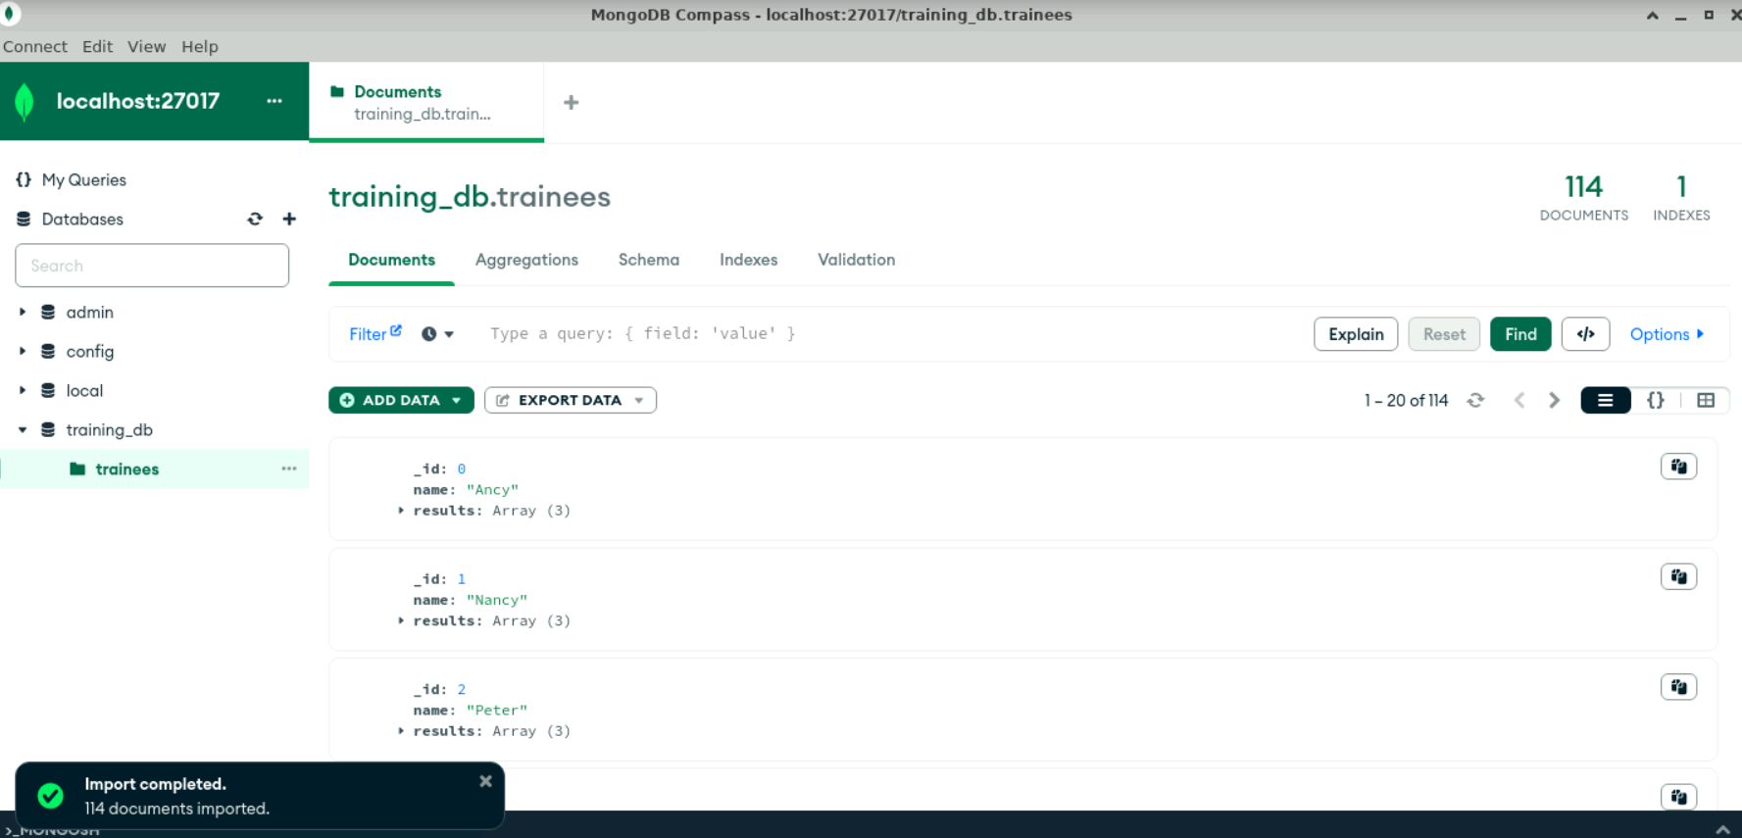

### Step 3: Writing Queries for Analysis in MongoDB Compass

1. **Find count and percentage of employees who failed in term 1 (passing score being 37)**:
   * Go to the trainees collection.
   * Click on the Aggregations tab.
   * Add the following stages:

1. **Find employees who failed in aggregate (term1 + term2 + term3)**:

* Go to the trainees collection.
* Click on the Aggregations tab.
* Add the following stages:

1. **Find the average score of trainees for term 1**:

* Go to the trainees collection.
* Click on the Aggregations tab.
* Add the following stages:

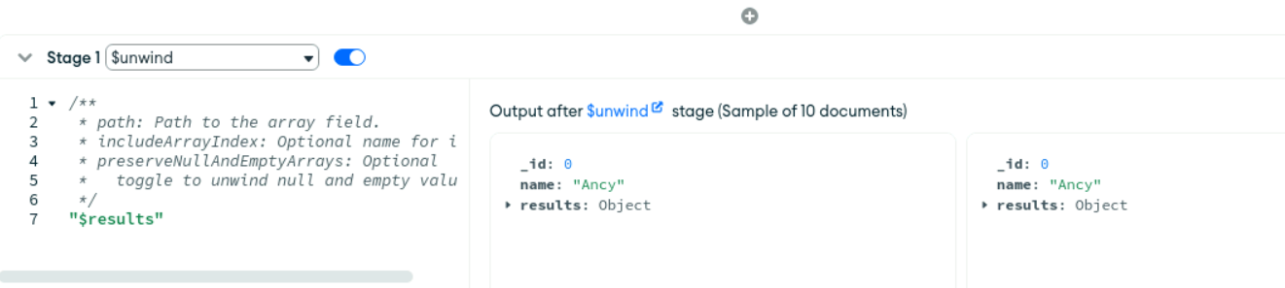

1. **Find the average score of trainees for aggregate (term1 + term2 + term3)**:

* Go to the trainees collection.
* Click on the Aggregations tab.
* Add the following stages:

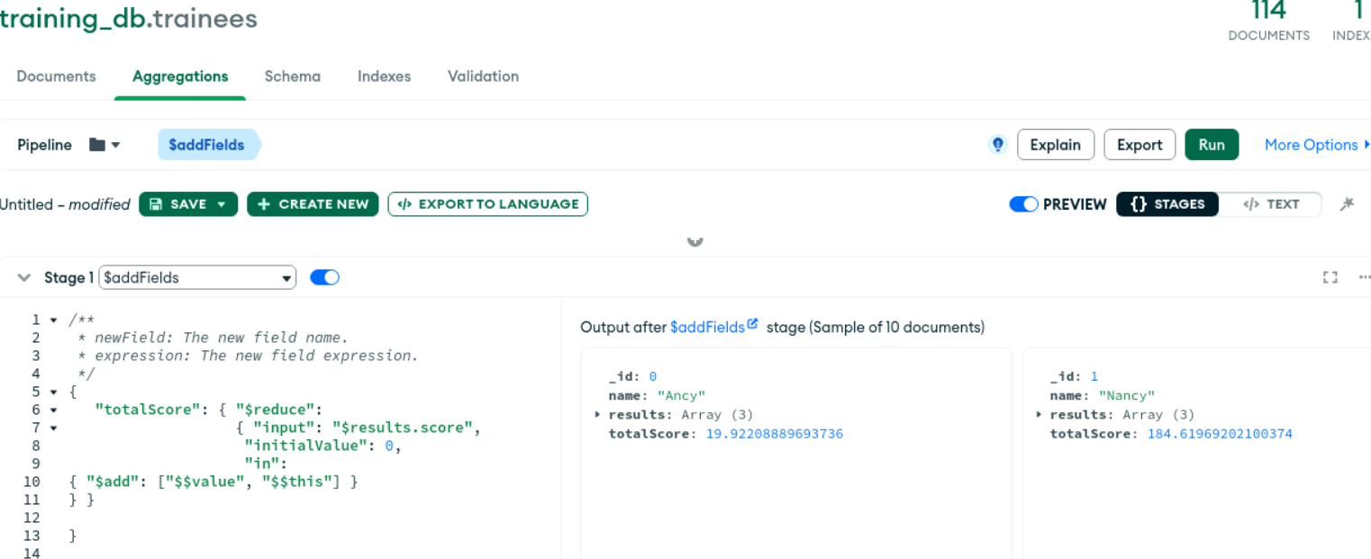

1. **Find the number of employees who failed in all three (term1 + term2 + term3)**:

* Go to the trainees collection.
* Click on the Aggregations tab.
* Add the following stages:

1. **Find the number of employees who failed in any of the three (term1 + term2 + term3)**:

* Go to the trainees collection.
* Click on the Aggregations tab.
* Add the following stages:



